Title; No Blank Line Between the Title and the Paper Top Margin; Page-Centered; MAX. 2 LINES

SURNAME N.1, SURNAME N.2, SURNAME N.2,* and SURNAME N.1

1Affiliation and address

2Affiliation and address

*corresponding author:

e-mail: xxxxxxxxxxxxxxxx

**PREPARATION AND SUBMITTAL**

The Book of Abstracts-in-Depth, which will be given to participants at registration, will be reproduced directly from your manuscript. Abstracts must be produced to fit A4 paper. The text, together with tables, equations and illustrations, must fill no more than one page, in 2-column layout (as in this accompanying example).

**SUBHEADING**

Authors are required to supply Abstracts-in-Depth as computer files (MS Word). Submissions can be received via online abstract submission system or via email [registration@dmpco.gr](mailto:registration@dmpco.gr).

**SUBHEADING**

The official language for the Abstract of the conference: English. Paper Format: A4 portrait. Margins: All the margins should be 2.0 cm from Top and 1.5 cm Bottom, 2 cm from Left and Right. Columns: main text in two columns, justified; equal column width. Spacing: before and after: 0 pt: line spacing: single. Font: for the title: size 12 Times New Roman, normal letters, bold; for the names of the authors: size 10 Times New Roman, capital regular; for the text: size 10 Times New Roman, regular. Page numbering: no page numbers. Title: leave no blank line between the title and the paper top margin; the title must be in bold regular letters, page-centered; maximum of two (2) lines.

Name(s) of authors(s): leave 1 blank line after the title; the name of the authors and their affiliations must be presented as succinctly as possible, including the e-mail address of corresponding author; Main text: in 2 columns, one page only, including figures and tables; paragraphs separated by one line. Footnotes: do not use footnotes.

**SUBHEADING**

Mathematics: equations should be typed into the body of the text, or incorporated as an equation editor or graphic object; equations should be numbered. Bibliographic references: in the text, indicate the last name of the author (no initials, please) followed by the year of publication in brackets; if there are several references of the same author in the same year, use a suffix a, b... after the year; make a list of references at the end of the text sorted by alphabetic order of the last name of the first author, followed by the names of the co-authors (if any), editor, place and year of publication (or complete reference of the journal where the article or paper was published).

File format for submission: use doc or docx format (size must be less than 2 MB); identify the files as “Abstract_<number of your abstract>.doc”. Send it by no later than March 29, 2019 via online submission system.

If you have any queries on the preparation of your abstract, please contact the Secretariat of DMPCO_2019 e-mail: [registration@dmpco.gr](mailto:registration@dmpco.gr), [lhw@central.ntua.gr](mailto:lhw@central.ntua.gr)

**ATTENTION**

Please note that this example of the one-page Abstract- in-Depth is a style sheet, which makes the work much easier. Please do not try to include more text on the single A4 page than the space provided by this instruction. If your one-page abstract does not comply with this instruction, it will be rejected.

**REFERENCES**

Within the text: Surname no initials please (year of publication in brackets 2013):

Author, co-author (2019): Title, Coastal Engineering, vol. 10, pp. 32-39.

Examples:

Belibassakis, K, Tsoukala, V and Katsardi, V (2014): Three-dimensional wave diffraction in the vicinity of openings in coastal structures, Journal of Applied Ocean Research, vol. 45, pp. 40-54.

Chatjigeorgiou IK, Chatziioannou K, Katsardi V, Koukouselis A, Mistakidis E (2018): Numerical and experimental investigation of the wave loading on a three-legged offshore wind turbine jacket platform. In 37th International Conference on Ocean, Offshore & Arctic Engineering. Paper No. 78416, Madrid, Spain, June 17-22 doi:10.1115/OMAE2018-78416.

**Examples of figures and tables format**

Figures and tables: include thefigures and tables precisely in the place you want them. Spacing: before and after table and figures captions: 2 pt.

**Table 1.** Title of the table

|  |  |
| --- | --- |
| **Text** | **Text** |
| Text | Text |
| Text | Text |

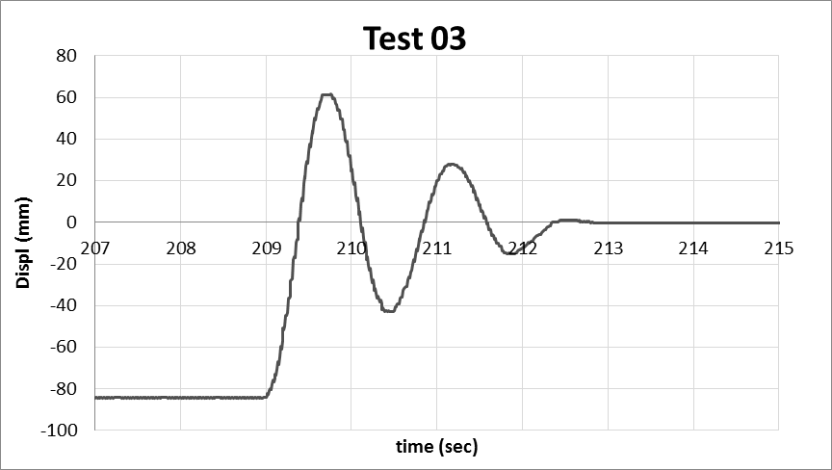

**Figure 1**. Free oscillation experimental tests