**Instructions for extended paper preparation for the DMPCO 2019 Conference**

J.L. First1*, P.L. Second2, J.C. Third2

1Department of l Civil Engineering, University of Somewhere, City, Region, Postcode, Country

2Department of Chemical Physics, University of Elsewhere, City, Region, Postcode, Country

*Corresponding author: [j.first@somewhere.edu](mailto:j.first@somewhere.edu)

**Abstract**

Begin each manuscript with an abstract that summarizes the content of the manuscript in 150 to 250 words. Leave two blank lines after Corresponding’s author email. Don’t include reference citations or undefined abbreviations in the abstract, since abstracts are often read independently of the actual chapter and without access to the reference list. Please also add two to four key-words. Each keyword phrase should start with an uppercase letter. When selecting the keywords, think of them as terms that will help someone locate your chapter at the top of the search engine list using, for example, Google. Very broad terms (e.g. ‘Case study’ by itself) should be avoided as these will result in thousands of search results but will not result in finding your manuscript.

**Keywords** First keyword, Second keyword, Third keyword, Fourth keyword.

1 First Section

This template was prepared to help structure your manuscript, e.g., define the heading hierarchy.

1.1 Manuscript length

The manuscript length, including tables, figures and references, should not exceed 5 pages, in the format of this template. Use A4 page set-up and make all margins (top, bottom, left, right) 25 mm wide. Use 11 pt Times New Roman font (except for the title which should be in 12 pt bold and affiliations, table and figure titles which should be 10 pt normal). Centre the title, the authors’ names, the addresses and corresponding author ‘s email address. Please compose a title that clearly and succinctly describes the content of your work in order to maximise its impact.

Start each paragraph, with no indent. Advise this template for paragraph (before/and or after) spacing. Justify the body of the text both left and right. Do not use page numbers. Uniformity of extended paper style makes the work much easier to digest!

2 Manuscript preparation

Either British or American English can be used, but be consistent within your manuscript. Check for consistent spelling of names, terms and abbreviations, including in tables and figure legends.

For American spelling please consult Merriam–Webster's Collegiate Dictionary; for British spelling you should refer to Collins English Dictionary.

If English is not your native language, please ask a native speaker to help you or arrange for your text to be checked by a professional editing service. Please insert their final corrections into your data before submitting the manuscript.

2.1 Headings and Heading Numbering

Heading levels should be clearly identified using this template, and each level should be uniquely and consistently formatted and numbered using the decimal system. Never skip a heading level.

2.1.1 Heading Levels

Up to three numbered heading levels should be used within a paper (H1, H2 and H3). Displayed headings must always keep to the hierarchical sequence. For example, it is not possible to use a heading 3 immediately after a heading 1.

Headings have no end punctuation or period after the heading number. H1 Level is Capital Bold while in H2 and H3 Levels all major words capitalized. Articles, conjunctions, and prepositions that are four letters or less in length, are not capitalized. For H2 use *bold italic* while for H3 regular fonts respectively*.*

2.1.2 Cross referencing

In cross-references, for hyperlink purposes, please refer to the section number (e.g., see Sect. 3.5.1), not to the page.

2.2 Terminology, Units and Abbreviations

Technical terms and abbreviations should be defined the first time they appear in the text. Always use SI units (<http://physics.nist.gov/cuu/Units/>).

Numerals should follow the British/American method of decimal points to indicate decimals and commas to separate thousands. If the manuscript contains a large number of terms and abbreviations, a list of abbreviations or a glossary is advised.

2.2.1 Emphasis and Special Type

Italics should be used for emphasized words or phrases in running text. Do not format entire paragraphs in italics. Bold formatting should not be used. Sans serif (e.g., Arial) and non-proportional fonts (e.g., Courier) can be used to distinguish the literal text of computer programs from running text. Please avoid footnotes or endnotes.

2.2.2 Equations

Use Microsoft Equation Editor or the Equation editor embedded in the Microsoft Office 2010 or later to create your equations, and insert the graphic into your text file as an object. Displayed equations are numbered, with the equation number to the right of the equation. For example, the Euler equation is written as follows:

$e^{jπ}+1=0$ (1)

where $e$ is Euler's number, the base of natural logarithms, $j$ is the imaginary unit, which satisfies $j^{2} = -1$, and π is pi, the ratio of the circumference of a circle to its diameter.

Text references to equations take the forms “Eq. 6” or “Eqs. 6 – 8”.

2.3 Tables

Give each table a heading (caption). Add a reference to the table source at the end of the caption if necessary. Number tables consecutively (e.g. Table 1, Table 2, etc.) and ensure that all tables are cited in the text in sequential order. Do not write “the following table”. Text references to tables take the forms “Table 1” or “Tables 2 - 4”.

Use the table function to create and format tables. Do not use the space bar or multiple tabs to separate columns and please do not use Excel to create tables as this can cause problems when converting your tables into the typesetting program and other formats.

Do not manually insert table rules in the manuscript, because they cannot be retained. Simple, one-column lists should not be treated as tables.

**Table 1** Table captions have no end punctuation and no period after the table number

|  |  |  |  |  |
| --- | --- | --- | --- | --- |
|  | Column1 | Column2 | Column3 | Column4 |
| Row1 |  |  |  |  |
| Row2 |  |  |  |  |
| Row3 |  |  |  |  |

2.4 Figures

Give each figure a concise caption, describing accurately what the figure depicts. Number figures consecutively (e.g. Figure 1, Figure 2, etc.) and ensure that all figures are cited in the text in sequential order. Do not write “the following figure”. If a figure is reproduced from a previous publication, include the source as the last item in the caption. Text references to figures take the forms “Figure 1” or “Figures 2 - 4”.

Please consider a minimum size of 2 mm (6 pt) for text within a figure. Use lowercase letters for part figure labels.

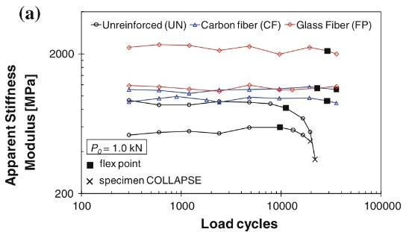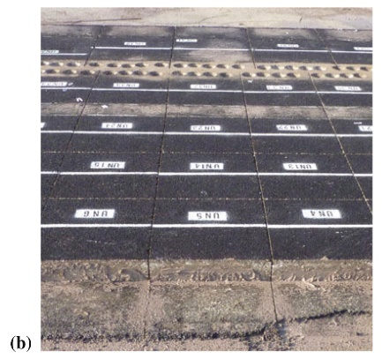

**Figure 1** Figure captions have no end punctuation and no period after the figure number: a) First part of the figure, b) Second part of the figure

Color figures will appear in color in the eProccedings.

2.5 References

Cite references in the text with author name/s and year of publication in parentheses (“Harvard system”):

* One author: (Miller 1991) or Miller (1991)
* Two authors: (Miller and Smith 1994) or Miller and Smith (1994)
* Three authors or more: (Miller et al. 1995) or Miller et al. (1995)

2.5.1 Reference list

Include a reference list at the end of the paper. Include all works that are cited in the text and that have been published or accepted for publication. Personal communications and unpublished works should only be mentioned in the text. Do not use footnotes as a substitute for a reference list.

Entries in the list must be listed alphabetically. The rules for alphabetization are:

* First, all works by the author alone, ordered chronologically by year of publication
* Next, all works by the author with a coauthor, ordered alphabetically by coauthor
* Finally, all works by the author with several coauthors, ordered chronologically by year of publication

References

Example references are listed below.

* Journal article

Slifka MK, Whitton JL (2000) Clinical implications of dysregulated cytokine production. J Mol Med 78:74–80. doi:10.1007/s001090000086

* Book, authored

South J, Blass B (2001) The future of modern genomics. Blackwell, London

* Book chapter

Brown B, Aaron M (2001) The politics of nature. In: Smith J (ed) The rise of modern genomics, 3rd edn. Wiley, New York, p 234–295

* Paper presented at a conference

Chung S-T, Morris RL (1978) Isolation and characterization of plasmid deoxyribonucleic acid from Streptomyces fradiae. Paper presented at the 3rd international symposium on the genetics of industrial microorganisms, University of Wisconsin, Madison.

* Online document

Doe J (1999) Title of subordinate document. In: The dictionary of substances and their effects. Royal Society of Chemistry. Available via DIALOG. http://www.rsc.org/dose/title of subordinate document. Accessed 15 Jan 1999

Extended paper review

The extended paper will be reviewed by members of the Scientific Committee of DMPCO 2019 Conference. The Scientific Committee will consider selected papers for review and possible publication in peer-review scientific journals (see for details in www.dmpco.gr)

The extended paper should be submitted in .**doc or .docx files** via the website: [http://www.dmpco.gr/registration.html](http://www.dmpco.gr/registration.html%20) . The deadline for extended paper submission is **15st April 2019**.